Social Media

Dark Reality

Rameez

Numl-F23-50489  Rameez Hassan Raja

Table of Contents and List of Figures

Contents

Preface II

Chapter no 1: 1

A little about social media 1

and the Internet. 1

Chapter 2: 2

Devastating Effects of Social Media: 2

Chapter 3: 3

What are we doing instead of 3

What we must be doing: 3

List of Figures 4

Feigure1: 4

Figure 2 4

Figure 3 4

Figure 4 4

Conclusion: 5

Delete your Social media account: 5

## Preface

My name is Rameez Hassan Raja. I am an undergrad student at NUML University. I am writing all of this for our youth for this generation and also for the next generation. Well as you know I will be talking about Social media. I will not write about the advantages of social media. You all know me very well than me Because you all use social media. I will talk about the devastating effects of social media. I am dedicating all my research to those people who told me to leave social media. So let's start.

# 

# Chapter no 1:

## A little about social media

## and the Internet.

The origins of social media can be traced back to the early days of the Internet and the evolution of computer networking. During the 1970s and 1980s, online communities began to take shape as computer networks emerged. Bulletin Board Systems (BBS) provided a platform for users to connect through modems, enabling the exchange of messages and files in a primarily text-based format. The 1980s also saw the establishment of Usenet, a decentralized discussion system where users could post and read messages in various newsgroups, laying the foundation for modern discussion forums. In the 1990s, the World Wide Web was introduced, bringing a more visually appealing and user-friendly interface. This era witnessed the emergence of online diaries and personal web pages, marking an early stage of self-expression and social interaction. In 1997, Six Degrees emerged as one of the first social media platforms, allowing users to create profiles and connect with friends, although it lacked many of the features found in modern platforms. These significant milestones collectively influenced the development of social media. In 2004 teen teenager Mark Zucker Burgh brought a revolution in this world regarding social media. Today social media is a multi-billionaire company.

# 

# Chapter 2:

## Devastating Effects of Social Media:

One of the issues with social media, it's been pointed out by many people, is that I think maybe particularly Instagram, people look like they have a much better life than they do. Right, by design. Yeah, people are posting pictures of when they're really happy, they're modifying those pictures to be better looking. Even if they're not modifying the pictures, they're at least selecting the pictures for the best lighting and the best angle so people seem they're way better looking than they are right and they're way happier seeming than they are so if you look at everyone on Instagram you might think the man they're all these happy beautiful people and I'm not that good looking and I'm not happy so I must suck you know you know, and that's gonna make people sad. So when in fact, those people you think are supper happy no they are not that happy. You can't see behind the scenes. So super and happy people looking people can be the most worried people in the world

# 

# Chapter 3:

## What are we doing instead

## What we must be doing:

So after waking up in the morning instead of doing push-ups or drinking a glass of water we just take mobile and scroll through social media. Pathetic.

Instead of doing our chores or instead of taking care of our business we just suck around social media.

To avoid excessive use of social media, individuals have the opportunity to enhance their lives by participating in a range of offline activities. It is important to prioritize face-to-face interactions with friends and family to nurture genuine relationships. Devote time to reading books, immersing oneself in captivating stories, and expanding knowledge. Rediscover or develop hobbies and interests, whether through artistic pursuits, physical activities, or culinary endeavors. Embrace new skills or hobbies by taking online or offline courses to encourage continuous learning. Contribute to the community through volunteering, fostering a sense of purpose and fulfillment. Make physical health a priority by incorporating regular exercise routines that align with personal preferences. Implement mindfulness practices, such as meditation, to reduce stress and promote mental well-being. Establish limits on screen time and set boundaries for social media usage to maintain a healthy balance between online and offline activities. Spend time outdoors and reap the rejuvenating benefits of nature. Strengthen existing relationships by nurturing real-life connections and appreciating their depth. By embracing these alternatives, individuals can enrich their lives and find fulfillment outside of excessive social media consumption.

# 

# List of Figures

## Feigure1:



### Figure 2



### Feigure 3



### Feigure 4



# 

# Conclusion:

## Delete your Social media account:

The choice to eliminate or restrict the use of social media is a personal decision, and individuals often have various reasons for taking such action. One common motive is the desire to manage time effectively. Social media platforms, with their constant flow of content, can consume a significant amount of time, leading to procrastination and decreased productivity. By removing social media from their routine, people aim to regain time for more meaningful and purposeful activities.

Another important consideration is mental well-being. Excessive use of social media has been associated with mental health issues like anxiety, depression, and low self-esteem. The constant exposure to carefully curated and idealized portrayals of others' lives, combined with the pervasive culture of comparison, can have negative effects on mental health. Deleting or limiting social media usage becomes a strategy to protect and improve one's psychological well-being.

Privacy concerns also factor into the decision to disengage from social media. With the widespread sharing of personal information, individuals may feel vulnerable to privacy breaches. Deleting or limiting social media usage can be a way to safeguard one's privacy.

Report of Lab Exam

**Name:** Rameez Hassan Raja

**Class:** BSCS 1B

**System Id:** NUML-F23-50489

**E-mail:** numl-f23-50489@numls.edu.pk

**Word:**

Project Report: PowerPoint viva Excel and Word Assignments

Word Project: Document Formatting

Document Specifications:

The topic is regarding Social media.

The Word assignment involved the formatting of a document based on specific guidelines. The following requirements for formatting were followed:

**Margins:** The document's margins were adjusted according to the instructions provided. The left margin was set to 1.5 cm, while the right, top, and bottom margins were set to 1 cm.

**Paper Size:** The document was formatted to be printed on A4 paper, maintaining consistency with standard paper dimensions.

**Page Numbers:** The page numbers for the initial pages, such as the Title page, Table of Contents (TOC), and List of Figures, were formatted using Roman numerals. Subsequent pages, starting with the main content, were numbered using Arabic numerals.

**Headers:** Each chapter had its header displaying the corresponding chapter name. This promotes document organization and facilitates navigation.

This Word assignment demonstrated meticulous attention to detail, ensuring that the document adheres to the prescribed formatting guidelines. The structured layout and consistent formatting contribute to the overall professionalism of the document.

**Excel**

The Excel project focused primarily on analyzing data and calculating GPAs using specific criteria.

Calculation of Maximum OBT Marks:

To determine the highest value in the "OBT MARKS" column, a particular table in the Excel sheet was examined. This was accomplished by utilizing the MAX function, which offers a fast and efficient method for identifying the maximum value within the dataset.

Calculation of GPA:

A formula for calculating GPA was implemented to assign GPA values based on given percentage ranges. The IF function was employed to categorize percentages and assign the corresponding GPA according to the specified criteria.

The logic for GPA calculation is as follows:

* If the percentage is ≥ 80, the GPA is 4.00.
* If the percentage is between 77 and 79, the GPA is 3.66.
* If the percentage is between 74 and 76, the GPA is 3.33.
* If the percentage is between 70 and 73, the GPA is 3.00.
* If the percentage is between 67 and 69, the GPA is 2.66.
* If the percentage is between 64 and 66, the GPA is 2.33.
* If the percentage is between 60 and 63, the GPA is 2.00.
* If the percentage is between 50 and 59, the GPA is 1.50.
* If the percentage is less than 50, the GPA is 0.00.

This GPA calculation ensures a standardized evaluation of academic performance based on the specified grading scale.

Both aspects of the Excel project involved thorough data analysis and precise calculation methods to provide accurate results.

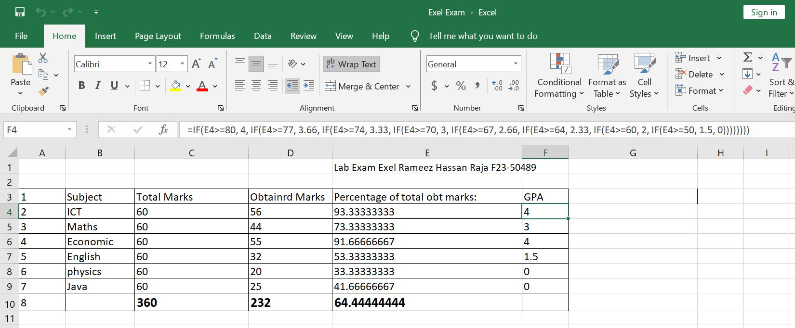

**PowerPoint:**

**Q1:** Explain the use of the following functions in MS PowerPoint:

Animations

Transitions

Slideshow

**Animations:**

Animations in PowerPoint pertain to the movement or motion applied to text, images, or other elements on a slide.

Entrance Animations: Introduce elements onto the slide.

Exit Animations: Make elements disappear from the slide.

Steps:

* Select the object you wish to animate.
* Navigate to the "Animations" tab.
* Choose an animation from the gallery.
* Adjust animation settings as necessary.

**Transitions:**

Transitions are effects that occur between slides, controlling how one slide transitions to the next.

Add professional and polished transitions between slides.

Enhance the flow and visual appeal of the presentation.

**Steps to apply**

* Go to the "Transitions" tab.
* Select a transition effect from the gallery.
* Adjust the transition duration and other settings.
* Apply the transition to one or all slides.

**SlideShow**

Slideshow refers to the presentation mode where slides are displayed one after another in a sequential order. Usage: Present the content to an audience. Navigate through slides during a presentation.

It is a mode of presenting information where slides are shown in an order, one after another.

It is used to deliver content to an audience. During a live presentation, it allows the presenter to navigate through the slides. It also provides a preview of how animations and transitions will appear in the final presentation.

**Steps:**

* click on the "Slide Show" tab.
* Choose either "From Beginning" to start from the first slide or "From Current Slide" to start from the current slide
* Utilize the navigation controls to move between slides. When finished presenting, exit the slideshow.